Project Design Phase-II
Technology Stack (Architecture & Stack)

Date | 15/02/2026
Team ID | SWTID-2026-4180
Project Name | Contact Manager
Maximum Marks | 4 Marks

Technical Architecture:
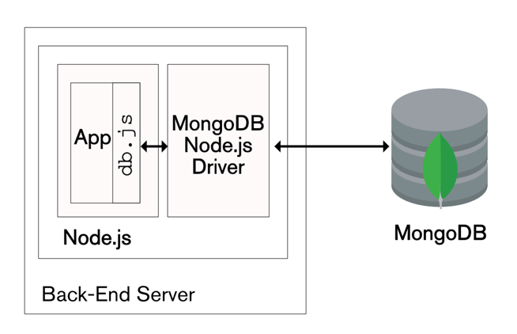
The user interacts with the system through the application interface. The request is processed by the Node.js and Express backend server, which communicates with the MongoDB database to store and retrieve contact information.

Table-1 : Components & Technologies

S.No | Component | Description | Technology
1 | Application Logic | Handles storing and updating contact data | Node.js, Express.js, MongoDB
2 | Data Processing | Handles retrieval of contact information | Node.js, Express.js
3 | Database | Stores contact details and user information | MongoDB
4 | API Layer | Provides communication between frontend and database | REST API

Table-2: Application Characteristics
S.No | Characteristics | Description | Technology
1 | Open Source Framework | Backend development framework | Node.js, Express.js
2 | Scalability | Handles multiple users and contacts efficiently | MongoDB
3 | Security | Secures API access and authentication | JWT Authentication
4 | Data Storage | Stores user and contact data | MongoDB Database

